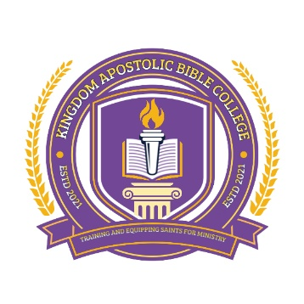
Address: 3402 Dixie Avenue, Villa-Liza ext2, Boksburg 1459
Email: apostle.amg@gmail.com
Cell: 0813823970 / 0624430299
Facebook: Christ through all gospel outreach ministries

COURSE OUTLINE

Certificate in Church Governance
1. Introduction to Church Governance: Foundational concepts and principles.
2. Church Leadership: Roles and responsibilities of church leaders.
3. Church Polity: Basic understanding of church government structures.
4. Conflict Resolution: Managing conflicts in the church.

Diploma in Church Governance
1. Church Government Structures.
2. Leadership and Management.
3. Church Law and Policy.
4. Strategic Planning.

Bachelor's Degree in Church Governance
1. Advanced Church Leadership.
2. Church Governance Models.
3. Conflict Resolution and Mediation.
4. Church and Community Engagement.

Master's Degree in Church Governance
1. Theological Foundations of Church Governance.
2. Advanced Church Leadership and Management.
3. Church Governance and Ethics.
4. Research Methods in Church Governance.

Doctorate in Church Governance
1. Advanced Research in Church Governance.
2. Theories of Church Governance.
3. Church Governance and Leadership in a Global Context.
4. Dissertation

